My adventure in Cameroon
Written by Gemma Jackson
Play Specialist at Wycombe Hospital
As most days begin in the same way, I did not expect 9th September to be any different, but as I left the ward and walked home I became more and more excited about the fact that I had agreed to go to Cameroon with Dr Alison Earley and Maternal and Childhealth Advocacy International.
Dr Earley told me that I would fly from Heathrow airport to Douala in Cameroon, Africa. It was then explained that I would travel the next day to Bamenda where I would work in the hospital, volunteering in the playroom with Evodia the play nurse who ran the playroom.
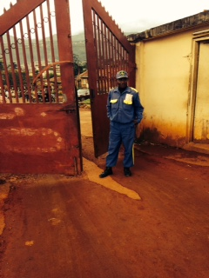

This is the front entrance to Bamenda hospital.

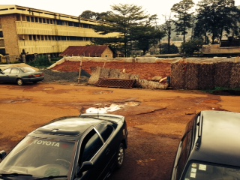

This is the car park at the hospital

Dr Earley, Dr Skinner, Dr Cross, Dr O`Halloran and I arrived the first morning at the hospital where we were shown around the grounds. Dr Earley and co were training professionals in the learning centre. I was able to communicate with them when necessary.
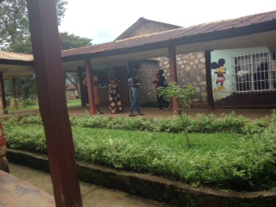

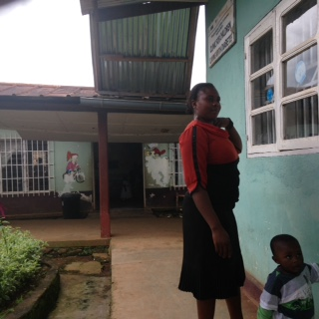
Outside the playroom in the hospital grounds.
Opposite is the waiting room where many of the children wait to see the doctors during clinic times. I suggested that a sign should be put up in the waiting room to encourage the parents to take the children to the playroom.

I arrived at the playroom and I was struck by how there was no sign on the door, something so simple but essential for the promotion of the playroom. I noticed the waiting room next to the playroom which had a large number of children and parents waiting to see doctors for the majority of the day. The number of children in the waiting room increased and many were seen to be crying with little to distract or entertain them.
I was introduced to one of the doctors who gave me the key to the playroom cupboard. I opened it to see a shortage of toys and the bare essentials needed to provide activities for children. I had brought two large cases to Cameroon which were full of toys, paper, card and equipment, most of which was very kindly donated by Starlight. I was able to fill the cupboard and when Evodia arrived she was very grateful for the donations.
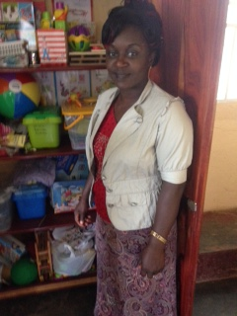
This is Evodia the Play Nurse stood, at the cupboard in the playroom looking at the new toys donated.
I worked alongside Evodia who was incredibly enthusiastic about play and how it helps children in hospital. We discussed new strategies to promote the playroom and play facilities. These included informing the parents during clinic times that the playroom is open and providing play for all the children in the hospital by taking toys to the ward for those children who stayed in hospital long or short term. These strategies ensured all the children were able to access play within the hospital grounds. This was important as play in hospital has been proven to relieve stress and help develop coping mechanisms, Hubbuck (2009) , Play in Hospital.

I encouraged Evodia to provide outside play as much as possible. This would ensure the children were getting exercise while having fun and developing social skills and the opportunities for play would be increased.
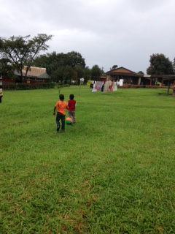
A picture some children playing football in the hospital grounds

Evodia and I organised all the equipment I had provided for the children and prepared a creative activity for children in the playroom. The children used paint and glitter pens and made their own pictures and designs. I reinforced the need for children to have the opportunity to make their own decisions in hospital. Evodia, being a trained children`s nurse, was very empathetic and understood that children do not choose to be in hospital so play is a chance for a child to gain some control and express themselves, Hubbuck (2009).
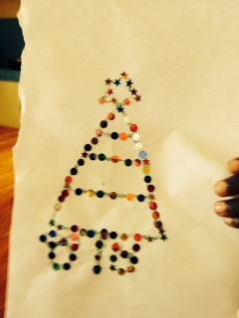
Pictures made by children and staff using sequins and glitter glue

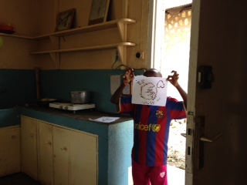
A boy who was proud of his glitter picture showing us inside the playroom In one of the clinics a nurse organised a blood clinic. Dr Earley explained to me that she had to do many blood tests for the children in the hospital. I took some distraction toys and went to see if I could help. I chatted to Inca the nurse and she explained to me that the children would get very upset and she found it hard as she did not want it to be upsetting for them. I offered the nurse a variety of toys for all ages and showed Inca how they could be used to distract the children or babies. I reinforced the importance of interacting with the child while distracting, using techniques such as talking, singing and keeping calm while the blood tests take place. I went to see Inca a few days later and she said she had begun to use the techniques and they had helped as the children seemed calmer.
While in the playroom Evodia and I had the opportunity to promote the playroom and play in hospital to two managing directors from another hospital in Cameroon. They wanted to start a play service in their hospital and understand how they could achieve this, who they should employ to run the service and what toys they should provide for their children suffering from HIV. I described my job role in the UK, how distraction with the use of toys helps to keep children calm, how pre and post procedural play helps older children to understand what is going to happen or is happening to them. I provided them with knowledge of the benefits of play in hospital and how and what types of activities could be available for children in hospital. The National Association for Hospital Play Specialists (2014).
Evodia shared her knowledge, feelings and experiences of how play in hospital helps and supports children in Cameroon. I recommended Evodia as a permanent contact and a possible advisor to the managing directors in helping the new play service to be set up. Evodia had been providing play opportunities at Bamenda hospital since November 2013. Sally Hitchings, a Play Specialist, began the play service with Evodia, who has been successfully providing play ever since.
I continue to work alongside Dr Alison Earley and the National Association for Hospital Play Specialists, to help the hospital in Cameroon provide play in the future. I also made recommendations to provide space and facilities for teenagers and I discussed these with Evodia.
While I played with the children and chatted to the parents, I learnt to speak clearly and slowly. Although they spoke English in Bamenda, I sometimes found it hard to understand what they were saying, though when asked they would repeat what they had said. At first some parents would look at me with surprise or confusion but ultimately everyone was friendly and welcoming. On my last day I was quite sad to be leaving as I said goodbye to the lovely Evodia and the great team in the hospital. I felt very privileged to have had the opportunity to volunteer there.

